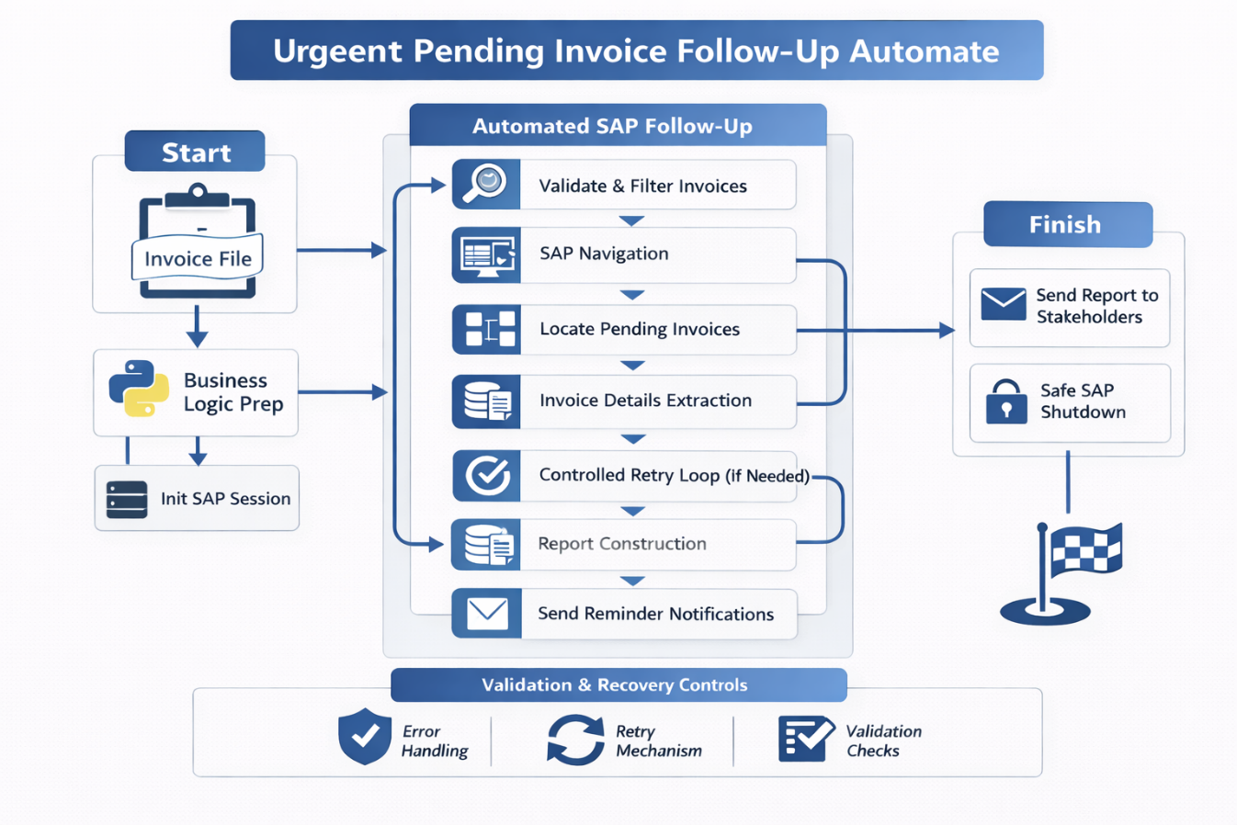

General process
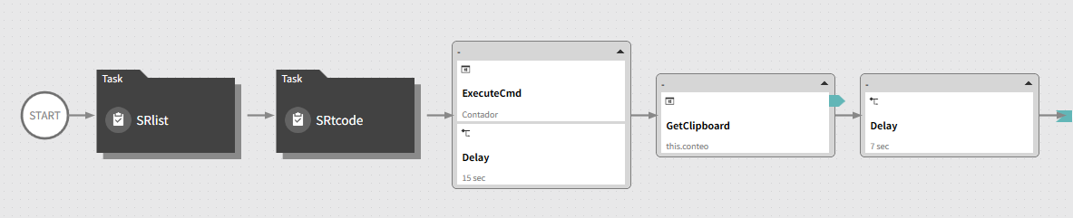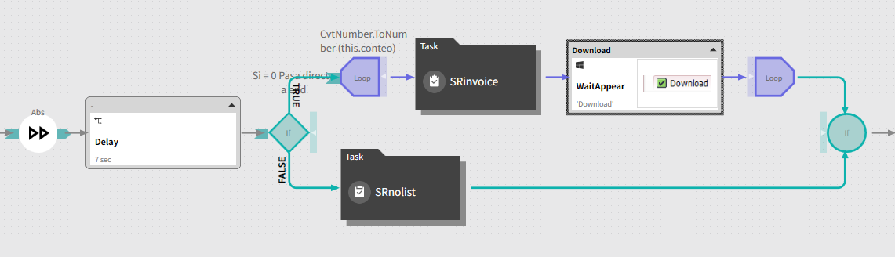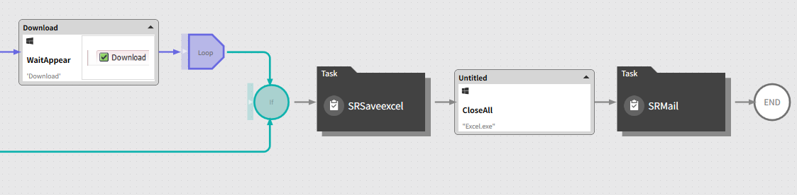

Innvoice list
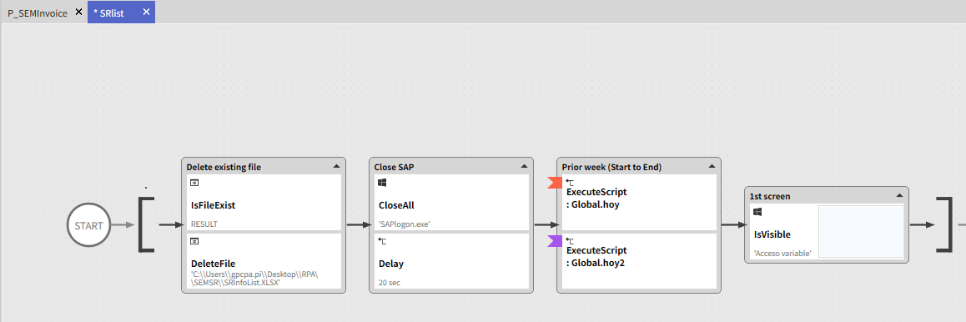
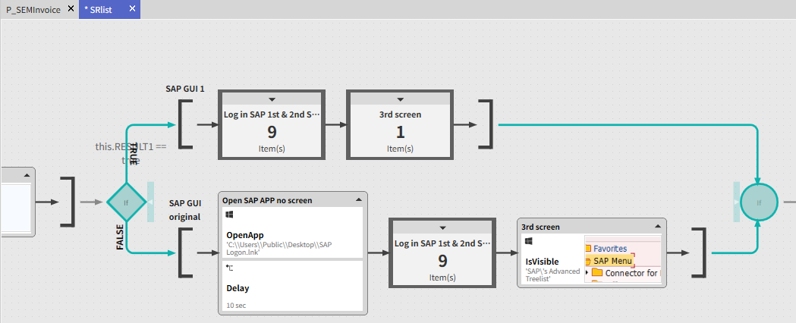
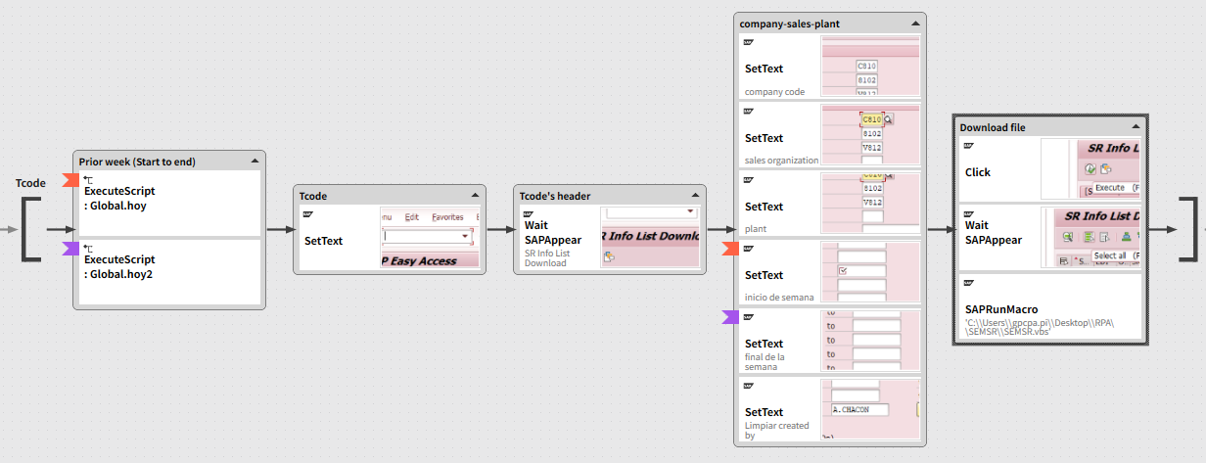
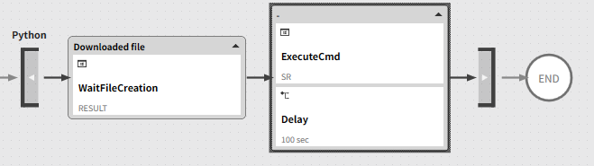
Innovice transaction
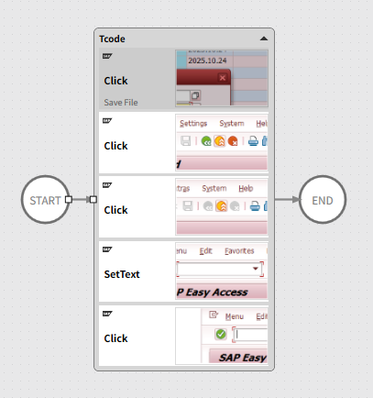
Innvoices
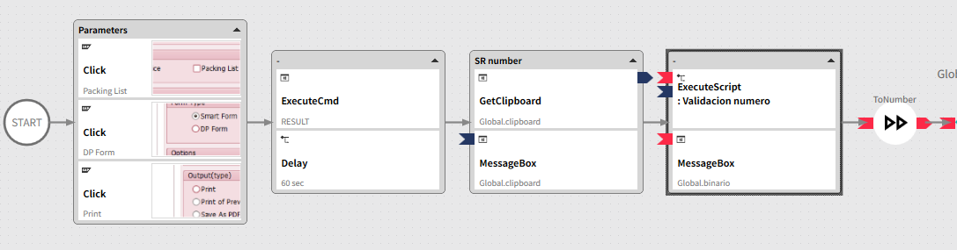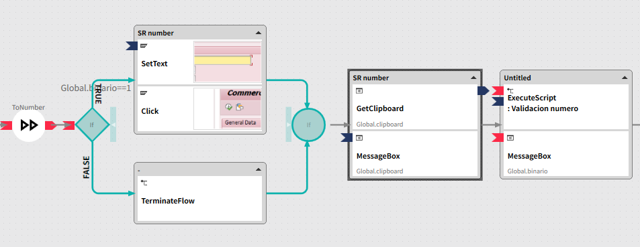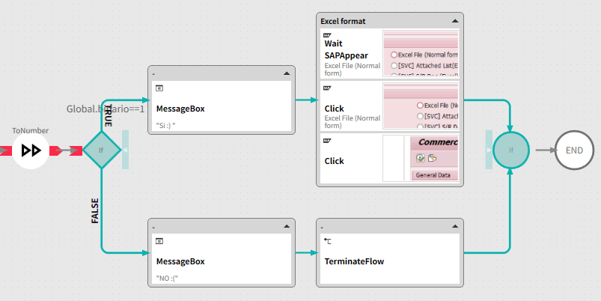
No innvoices
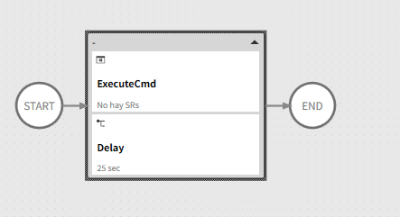
Save Excel of invoices
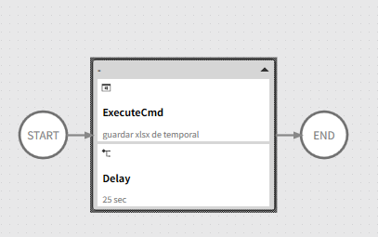

Send mail of invoices
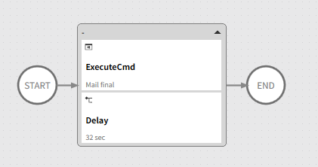
🚀 Executive Summary
Enterprise-grade RPA solution that automates the identification, extraction, follow-up, and reporting of pending SAP invoices.
The automation replaces a repetitive and error-prone manual process with a controlled, validated, and auditable workflow that ensures visibility, timely follow-ups, and consistent communication with stakeholders.

🎯 Business Problem
The pending invoice follow-up process was handled manually and presented multiple issues:
- Manual navigation across SAP SR and invoice screens
- High risk of missing overdue invoices
- Repetitive extraction and Excel handling
- Manual email preparation and sending
- No standardized reporting or traceability
This resulted in delayed collections, operational inefficiency, and lack of visibility over invoice status.

🧠 Solution Overview
A fully automated RPA solution was designed to manage pending invoices end-to-end, from SAP data extraction to Excel generation and automated email notifications.
The solution integrates SAP GUI navigation, Python-based business logic, structured reporting, and validation checkpoints to ensure reliable execution.

🖼 RPA Orchestration Breakdown
- Initialization & Setup
  - SAP session cleanup and controlled initialization
  - Load configuration parameters and execution rules
- SR List Extraction (SAP T-Code)
  - Navigate to SR List transaction
  - Extract relevant SR records
  - Validate SR data availability
- SR Invoice Processing
  - Navigate to SR Invoice section
  - Identify invoices with pending status
  - Validate invoice completeness
- Pending SR Identification
  - Filter SRs without invoice or with pending status
  - Apply business rules (dates, aging, relevance)
- Excel Generation
  - Save structured Excel report with pending invoices
  - Standardized columns and formatting
- Email Notification
  - Automated email with Excel attachment
  - Dynamic subject and message body
  - Delivery to defined stakeholders
- Safe Closure
  - Controlled SAP shutdown
  - Execution log finalization

📊 Results & Business Impact
- Significant reduction in manual effort
- Faster identification of pending invoices
- Improved follow-up discipline
- Standardized and auditable reporting
- Reduced risk of missed or forgotten invoices

🔍 Before vs After
Before
- Manual SAP navigation
- Dispersed invoice information
- Manual Excel creation
- Manual email follow-up
- High dependency on operator
After
- Fully automated invoice tracking
- Centralized and validated data
- Auto-generated Excel reports
- Automated email notifications
- Consistent and repeatable execution

🧩 Key Features
- End-to-end SAP invoice follow-up automation
- SR-based invoice tracking logic
- Automated Excel report generation
- Configurable email notifications
- Validation and recovery mechanisms
- Enterprise-safe SAP handling

🛠 Tech Stack
- SAP GUI Scripting
- Python (business rules, filtering, reporting)
- RPA Orchestration Platform
- Excel automation
- Email automation (SMTP / enterprise mail)

🧠 Challenges & Design Decisions
- Complex SAP navigation → Solved with defensive navigation and validation
- Risk of incomplete data → Implemented SR and invoice validation checkpoints
- Manual follow-up dependency → Fully automated reporting and notifications
- Stability concerns → Safe session cleanup and controlled execution flow

👤 My Role
- RPA Solution Architect
- Designed end-to-end automation flow
- Defined business rules for pending invoice detection
- Implemented SAP GUI automation and validations
- Built reporting and notification logic

🚀 Why This Project Matters
This project demonstrates how RPA can go beyond task automation and become a financial control enabler, improving visibility, accountability, and efficiency in invoice management while reducing operational risk.

